Condensation on windows is a problem in many households. Moisture in the air within the home is often the culprit. To prevent condensation on windows, you'll have to be proactive in stopping the accumulation of moisture in your home. Read the following tips to learn how to remove condensation on windows.

EditSteps
- 1
Tie back your curtains and open your blinds.
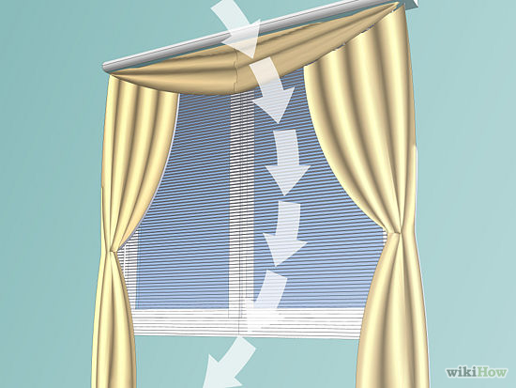
  - Opening your blinds can expose the surface of windows to circulating air. Leaving your curtains drawn can increase the amount of time it takes to remove condensation and even encourage the accumulation of it.
- 2

Circulate the air inside your home.
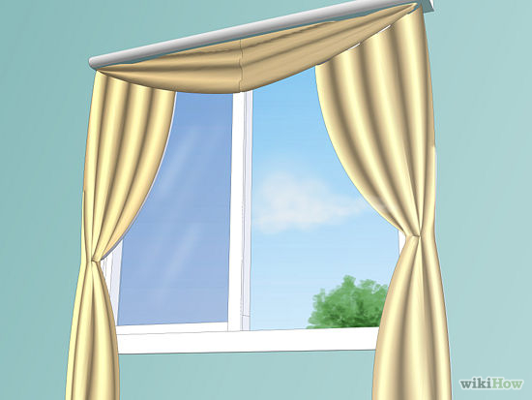
  - Mixing cold and warm air temperatures can help solve the problem of condensation. Open windows or doors if temperatures permit. If the temperature outside is too cold, turn on your fans.

Place a dehumidifier in the room where condensation occurs.
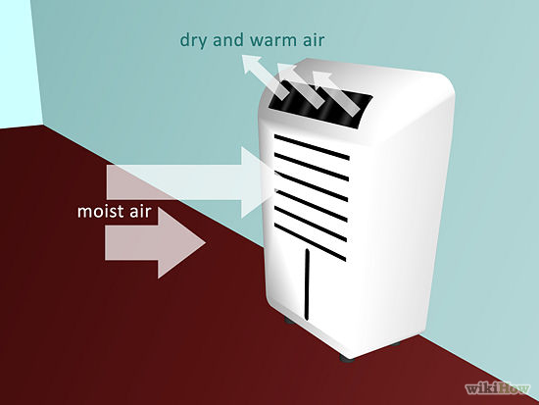
  - Dehumidifiers remove air-born moisture that contributes to condensation. To get the most out of this tactic, place the dehumidifier as close to your window as possible.
Verify that your window's caulking is adequate. Do repairs on them if necessary.
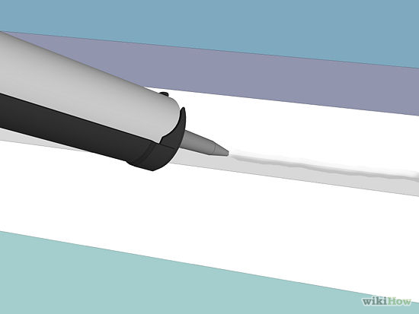
- 5
Make use of your vents and exhaust systems when cooking and showering.
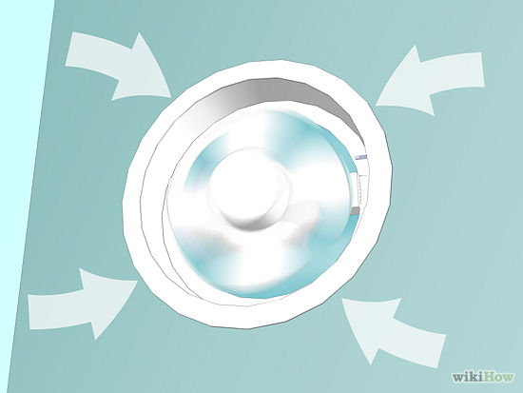
  - Cooking and showering encourage the accumulation of moisture in your home, which can lead to condensation on your windows. Run exhaust systems for about 15 minutes after each activity. If you don't have exhaust systems in your home, install them, and make sure that they exhaust at the rim joist, rather than the roof.
6

Recognize that your laundry room can be a source of moisture.
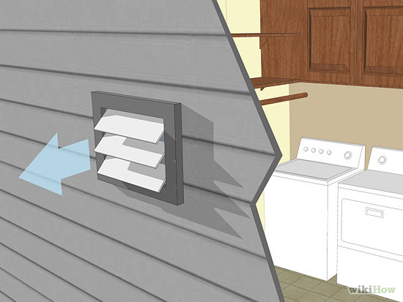
  - Dryer vents that are improperly installed are a common source of humidity in the home, which contributes to condensation on your windows. Make sure your dryer's vent is aimed towards the outside of your home and that it is adequately sealed so that no moisture escapes back into your home. Leaving damp laundry sitting in your laundry room can also contribute to the moisture levels in your home.
7
Repair unnecessary sources of moisture in your home.
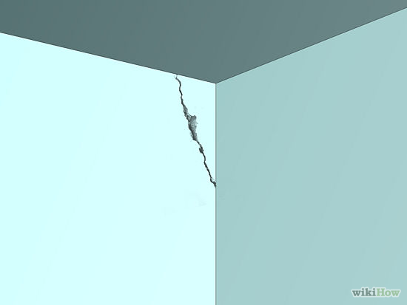
  - Cracks in walls and basement floors can increase the humidity your home. Seal them to see a reduction in condensation on your windows.
8
Check your vents for blockages and remove them if present.
